Document Information
Document Title: | SFI Research Centre Annual/Progress Report Template
SFI Associated Webpage: | SFI Research Centres Award Management
Direct Link to Document: | Research Centres Annual - Progress Report Template
SFI Team: | SFI Research Centres: Centres@sfi.ie
Document Type: | Template
Date Valid From: | 23rd Jan 2024
SFI Research Centre Annual / Progress Report Template
The Annual/Progress Report submitted by each SFI Research Centre provides SFI with an update on the progress of an SFI Research Centre, allowing for effective oversight and support by the Foundation. There is a requirement for each SFI Research to submit either an Annual Report or a Progress Report within a single calendar year. The reporting periods and the reporting deadlines change on whether an annual report or progress report is required for said calendar year.
This document is broken into 2 Parts:
- Research Centre Annual - Progress Report Background & General Instructions
- Research Centre Annual - Progress Report Template – outlining the required section headings, content outline and page limits requirements.
Document Version Tracker
Feb 2023 | - The budget template in section 2.3 has been updated. This update is in response to a number of Centre queries on the best way to complete the template, and to aid in the delivery of a clear and informative overview of the Centre budget.  - The EPE section, section 5, has been changed in line with recent discussions between SFI and the EPE Managers Forum, and evolutions in EPE strategies. The update to this section includes the addition of an embedded excel template for the EPE budget, and a template for additional EPE activities. It is requested that as well as graphs/tables being placed into the report that the completed excel files should be submitted along with the Annual Report.
23rd Jan 2024 | - Update of links, numbering and other formatting that had gone askew, and some very small updates to descriptions.  - The excels embedded in Section 5 EPE of the template has been updated and integrated into one file, to require details of EPE activities for all activities, including Flagship Programmes, and additional fields added to allow SFI to quantify and visualise EPE activities carried out by Research Centres, and to create a clearer picture of the offer and reach of EPE activities nationally. The narrative in Section 5 for these sections have been updated accordingly.

Purpose of the Annual/Progress Report
The Annual/Progress Report provides SFI with an update on the progress of an SFI Research Centre, allowing for effective oversight and support by the Foundation.
The Progress Report is a key document provided to expert reviewers ahead of site reviews of SFI Research Centres. Reviewers will receive a single Progress Report covering the period since the previous progress review. Note that they can request access to earlier Annual and Progress Reports if they deem it necessary.
Annual/Progress Reports enable SFI to inform key stakeholders and interest groups of the outputs, achievements and impact of the SFI Research Centres, including government departments, government agencies, the SFI Board, and the general public who ultimately fund the research. SFI works with these and other groups to develop and improve Ireland’s research ecosystem. For this reason, it is important that we understand the challenges and setbacks that SFI Research Centres face so we can continue to work to increase Ireland’s research potential.
General instructions
All instructions (including the grey text) through the template should be deleted/replaced in the final version. The report must include a cover page.
Section page limits are not target lengths, and it is up to Centres to decide how long is appropriate, up to the limit indicated. Duplication of information across section should be kept to a minimum. Section 2 (SFI Research Centre Overview) may contain some information that is also presented in other sections, but this should be in the form of a high-level summary. Likewise, Section 10 - Responses to Recommendations, can contain information duplicated in other sections.
Images do not count towards page limits, with the exception of the Executive Summary. Please note that screenshots of large amounts of text, text-filled tables, or other text-dense images will count towards page limits. The intention is to encourage images in order to make space for reports to be made more visually pleasing, to breakup large amounts of text, to illustrate a point, or to condense information down into an explanatory image. Screenshots of text or other similar text-dense images do not achieve these aims, and instead mean the document cannot be searched efficiently, and prevents copy-pasting of text.
All text should be in Times New Roman font or similar, with minimum font size of 11, and at least single-line spacing as well as a minimum margin size of 2.5cm. Text in diagrams should be in a clearly legible font. Include page numbers.
The document must be saved in a format that preserves links from the table of contents to individual sections in the report.
Please note that the final section, APPENDIX I – Research Activities, should be submitted as a separate file, and should have its own table of contents that links to each project.
Differences between Annual Report and Progress Report
Annual Report and Progress Report content differs in the following ways:
Sections for Inclusion | Annual Report | Progress Report
Section 1 - 10 | All sections to be included | All sections to be included
Section 11 – Centre’s Transition to Next Phase | N/A | Only completed in a Progress Report in advance of a 6-year review, where the Centre has been awarded funding for the next Phase.
Section 12 – Clinical Trials & Clinical Investigations | If applicable to your Research Centre | If applicable to your Research Centre
APPENDIX I – Research Activities (separate file) | Only Section A is completed. | Section A & Section B are to be completed
Report Submission Deadlines & Reporting Periods
Deadlines for submissions for this report will be communicated officially via SESAME.
An Annual Report covers the period since the previous Report (Annual or Progress), or the start of the award if no Report has been submitted yet, up to the date of submission (typically 30th April).
A Progress Report covers the period since the previous site review, or since the start of the SFI Research Centre’s activities if no site review has taken place yet, up to the date of submission (typically 3 months before the planned site review (can be in-person or virtual)). If developments occur between the date of submission of the Progress Report and the date of the site review, these developments can be presented at the site review. Please note that a Progress Report submitted as part of an SFI Research Centres call for proposals may be subject to a different template and reporting period.
The following image illustrates the reporting period covered by each report:

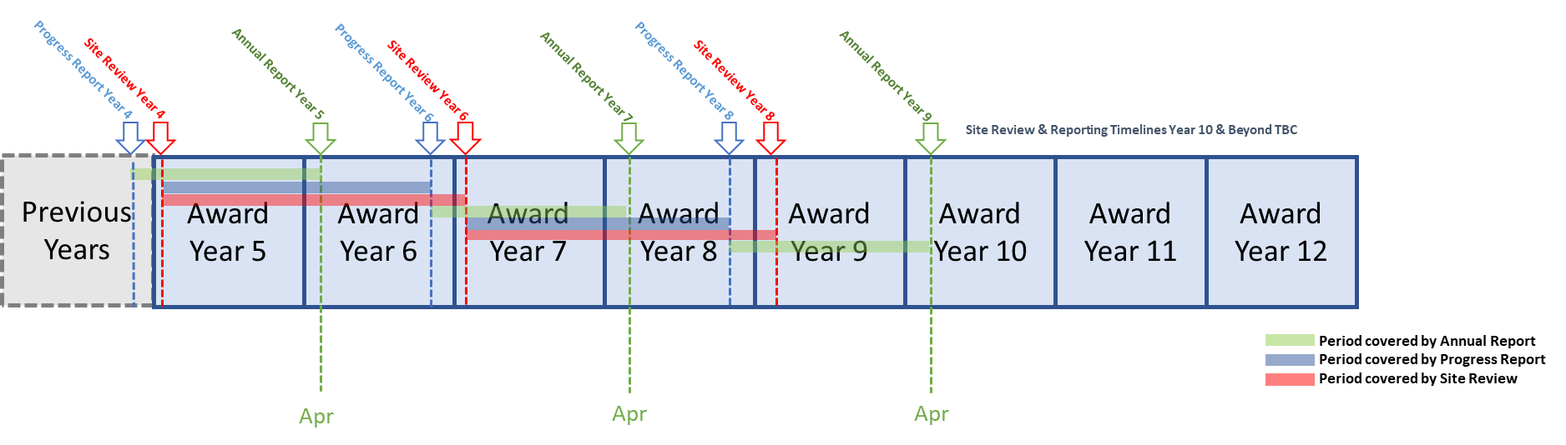
Figure 1: Reporting period illustration for annual and progress reports

Cover Page Placeholder

The front cover must meet SFI Research Centre branding guidelines, with the SFI branding lock-up above the title, and the host and partner institutions lock-up below. The full SFI Research Centre name should be used on the front cover, and the reporting type and period should be clearly indicated.

Contents
1. Executive Summary 1
2. SFI Research Centre Overview 2
3. SFI Research Centre Team 5
4. Research 6
5. Education and Public Engagement 8
6 KPI Performance 11
7 Funding Diversification 12
8 Centre Impact 13
9 Communications 14
10 Responses to Recommendations 15
11 Centre’s Transition to Next Phase 16
12 Clinical Trials and Clinical Investigations 17
APPENDIX I – Research Activities 18

1. Executive Summary (max. 2 pages)
The executive summary should be readable by a broad scientific but non-specialist audience.

  - Strategy
Comment on how the Centre is performing against its strategy, and whether any changes have been made to the Centres strategy during the reporting period. This should include new opportunities identified by the Centre.

  - Accomplishments
Summarise significant accomplishments during the reporting period. These can be from any area of the Centre’s activities, including research advances, industry engagement, EPE achievements, notable hires, etc.

  - Challenges
Discuss key challenges or setbacks the Centre has experienced during the reporting period, and how the Centre has responded to these challenges. Also note if any future risks have been identified, and summarise the actions being taken to manage or address these risks.

2. SFI Research Centre Overview (max. 8 pages, excluding images)
The title of this section can be replaced with ‘[Centre acronym] Overview’.

  - Strategy
Discuss the Centre’s strategy long-term direction.
Include alignment with current national priorities and industry sectors.
Present a SWOT (Strengths, Weaknesses, Opportunities, and Threats) analysis of the Centre.

  - Research Centre structure
Use a schematic to illustrate how the Research Centre is structured across research strands/themes, platform research, targeted projects, Spokes, C2C, etc.

  - Budget
Provide high level figures on the Centre’s SFI budget as well as industry and non-exchequer non-commercial funding (NE-NC) committed to and received by the Centre. The full SFI budget for the duration of the Centre should be displayed. Industry figures should include committed and received figures from signed CRAs. These industry figures should be combined cash and in-kind amounts. NE-NC figures should display all signed grants and other NE-NC, whether the project start date has been reached or not.

Specify the budgets allocated to both the research strands/themes/operations illustrated in section 2.2 (show Spokes and C2Cs separately) and the Centre’s partner Research Bodies, in two separate graphs using the template provided in the link below. If a portion of the SFI budget has not been committed to themes/Research Bodies and is being held in reserve, show this as a separate category on the graphs.

Use this embedded Excel template to generate the budget tables and plots from tabs 1) High-Level Budget, 2) Budget By Theme and 3) Budget By Partner Institute. Save the template locally before adding Centre data, and copy the data in as shown below.

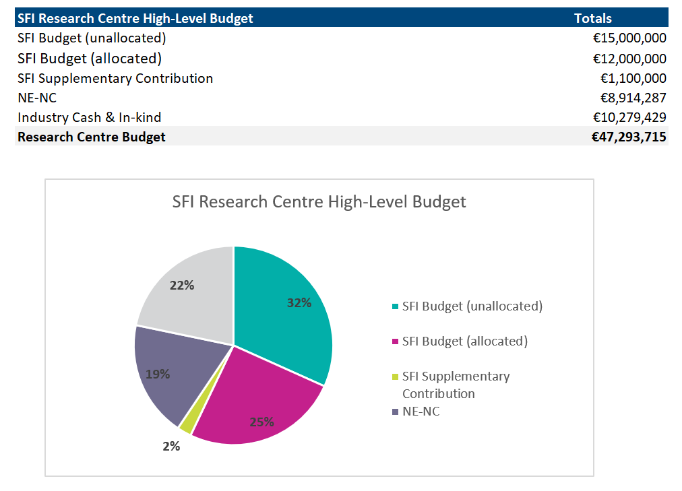
Figure 1 Example SFI Research Centre High-Level Budget
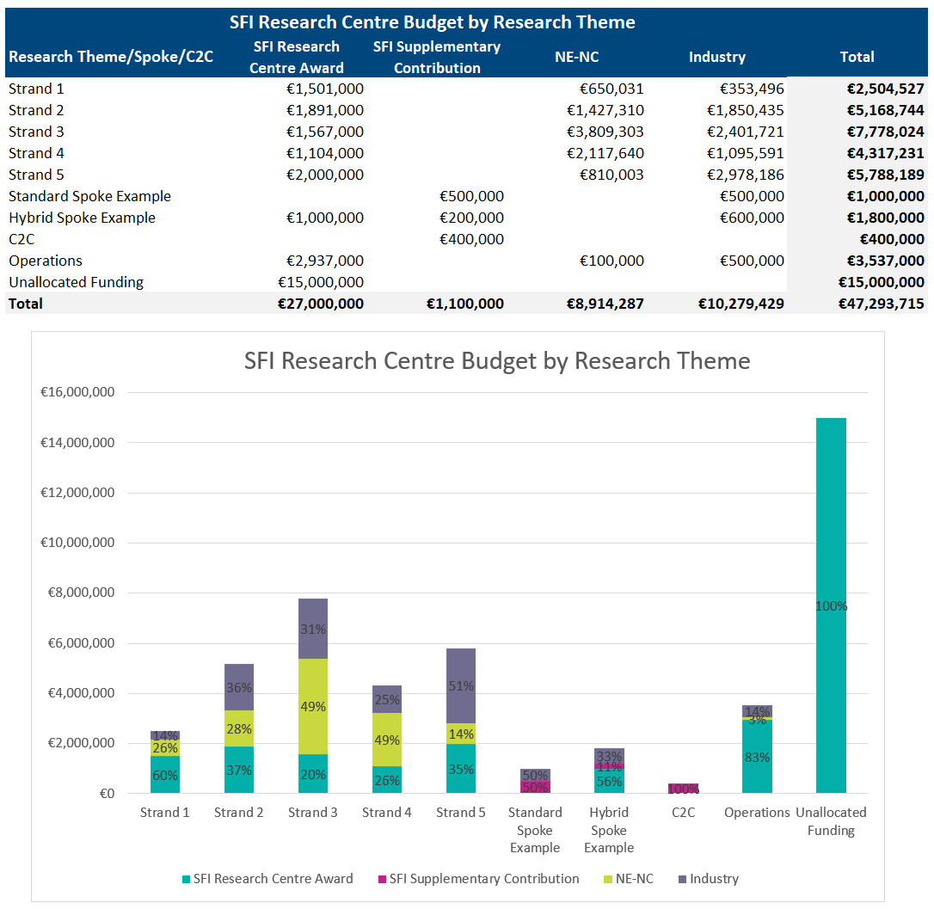
Figure 2 Example SFI Research Centre Budget by Research Strand / Theme

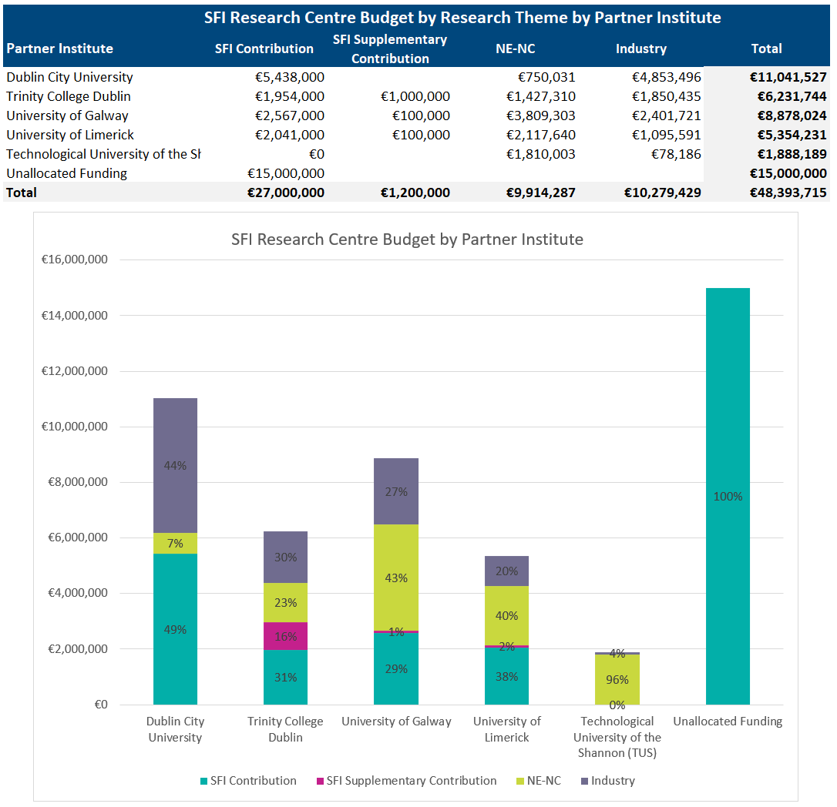
Figure 3 Example SFI Research Centre Budget by Partner Institute
  - International benchmarking
Benchmark the Centre against other, similar research entities around the world.

Ideally, benchmarking should aim to cover many of the same outputs and KPIs reported by SFI Research Centres, but benchmarking can include other factors that are deemed to be relevant comparators, such as personnel and budget.

Refer to any plans to address areas where the Centre does not perform highly internationally.

  - Collaboration with other research groups and Centres
Discuss active collaborations with other research groups and Centres, such as those that arose through EU-funded collaborative awards, C2C awards and Spokes. Detail any efforts to collaborate with other SFI Research Centres and highlight prominent collaborations established during the reporting period.

3. SFI Research Centre Team (max. 10 pages, excluding images)

The title of this section can be replaced with ‘[Centre name] Team’.

  - Leadership team
Present a high-level view of the Centre’s leadership team. This should clearly map to the Research Centre structure included in section 2.2 and detail the Directors, co-PIs that lead research strands/themes, and other key members of the Centre’s leadership.

  - Centre management and cohesion
Discuss the effectiveness of the Centre’s management, and how the Centre is transparently and effectively led. This may include strategic decisions, research project selection, research project evaluation and go/no-go decisions, personnel management, and other elements of Research Centre management.

This section should include the steps taken to create cohesion across the Research Centre, including across partner institutes, and to foster a positive and collaborative atmosphere.

  - Changes to Centre team
Detail any changes made to the Research Centre team during the reporting period and describe the impact that such changes have had on the Centre. (Changes to EPE team to be captured in Section 5).

  - Talent development and recruitment
Describe the Centre’s approach to talent development among its staff and researchers, and any significant activities that have taken place during the reporting period.
Comment on recruitment, with reference to any delays that have occurred, as well as future plans.

  - Gender equality
Discuss the Centre’s strategy and actions on gender equality across the Centre.

Please note that in the case of Centres with a KPI target for ‘gender balance of Centre leadership’, details of gender representation within the Centre’s leadership should be included as part of section 6. A shortened summary can be included here, with a reference to there being further information on the quantitative target as part of section 6. The section provided here is an opportunity to provide information on other aspects of gender equality in the Centre, and other team member levels, beyond representation within the leadership team.

  - Governance and Advisory committees
Provide a brief outline of the governance and advisory committee structures of the Centre.
List the members of these committees, and highlight changes in composition that occurred during the reporting period.
- Research (max. 10 pages, excluding images)

Please note that detailed updates on research projects should not be entered in this section, but instead should be entered in APPENDIX I - Research Activities (see below).

  - Research themes
Present each research theme/strand in the Research Centre. Include a short description of the aims and objectives of each theme.

Provide a detailed organisational chart for each theme that visualises the co-PIs leading that theme, and the co-PIs and FIs that also work in the themes. The overall budget assigned to the theme should be included in the chart, and the institution of each co-PI/FI should be visible.

A simplified example is shown below. Centres are free to use a style that suits the Centre best, once the requested information – research theme, PIs/FIs with Research Bodies, budget, and hierarchical structure – is clearly shown. The organigramme should be broken into separate themes/domains and/or displayed in landscape orientation if it is too large to be conveniently displayed on a standard A4 sheet.
Theme Budget: €…….
Research Body 4
Research Body 3
Research Body 2
Research Body 1
  - Changes to the Centre’s research structure
Discuss any significant changes to the research structure during the reporting period.

  - Notable breakthroughs and publications
Describe the most important breakthroughs that the Centre has made during the reporting period, clearly outlining what the breakthrough is, why it is important, how it has been translated and who has or will benefit from it. These descriptions should be understandable by non-experts. The number of breakthroughs presented here can be decided by each Centre.

Highlight the Centre’s ten most significant publications during the reporting period, include surrounding narrative that clearly explains, in non-scientific language, why these papers are important. These publications can include publications linked to the breakthroughs above, or can be in addition.

Explicitly reference where breakthroughs or publications have arisen from Spoke or C2C awards.

  - Good research practices
Good research practices are founded on the fundamental principles of research integrity. Outline how the Centre supports good research practices such as training, research protocols, data practices and management, and publication/dissemination.

  - Future plans
Describe the Centre’s plans for the next reporting period, highlighting any planned changes to the research programme.

- Education and Public Engagement (max. 10 pages, excluding images)

  - EPE strategy
Give an overview of the Centre’s EPE strategic plan, and high-level progress to date against the previous EPE operational plans for the reporting period. Highlight and explain any deviations from the strategic and operational plans.

  - EPE Team
Outline any changes to the EPE Team during the reporting period.

Identify your EPE Advocate (i.e. an individual who holds a leadership position and is a voice for EPE at an executive level) and how they have supported the EPE Manager and programme throughout the year.

Highlight your Centre’s EPE Champions and explain how they have been supported and nurtured throughout this reporting period. The definition of an EPE Champion is broader than just participation. Champions are identified as those who participate in five or more activities, who lead or significantly participate in the development and/or delivery of EPE strategy and/or activity. They often act as role models, inspiring others to participate.

  - EPE Flagship Activities
Provide an update on the 3 flagship EPE Programmes highlighted in your Annual Operations Plans for this reporting period using the format below. The narrative should provide sufficient updates on progress, links to external sources should only be used where necessary.

Flagship Programme Title

Flagship Programme Budget
Overall budget figure for this project, broken into SFI, industry cash/in-kind and NE-NC, as relevant.

Flagship Programme start date – end date

Vision and objectives
Include the target groups, why these groups were chosen, and if they include underrepresented groups.

Links to Research Programme
Please provide details on how this activity aligns to your Research Programme e.g. how is this thematically aligned or how can the learnings inform your Research Programme

Inputs
How many Centre staff members participated? What other inputs were required (consumables, equipment etc)? Did industry partners contribute staff time/resources?

Outputs
Outline the type of events/activities delivered. How many participants were directly engaged? Include a brief description of any challenges encountered, the causes and how they were overcome. Highlight any recommendations to help prevent similar challenges in future projects/activities.

Outcomes and evaluation
Outline the outcomes expected or achieved. Explain how you evaluated the programme – include methodology, findings and dissemination. Indicate whether objectives and expected outcomes were met/exceeded/not met, and why. Indicate where outcomes of an activity influenced other activities, in particular the research programme.

  - EPE Activities Summary
Please complete the embedded Excel Template for the Flagship Programmes and other key activities. Please insert the summary table into this report. Please ensure the completed excel document is submitted along with your Annual/Progress report.

SFI Research Centre EPE Activity Summary Report
Reporting Year | Flagship Programme  (drop down) | Primary Target Audience  (drop down) | Total Numbers Engaged | Total Number of Activity Days
 | Flagship Programme 1
 | Flagship Programme 2
 | Flagship Programme 3
 | Other
Table 1 Example SFI Research Centre EPE Activity Summary Report

  - EPE budget
Please complete tab 3 of the above embedded Excel template and present the EPE non-pay budget during the reporting period, separated into SFI (Research Centre & Discover Award), Industry and NE-NC sources. Please comment on the budget, and its sources. Please ensure the completed Excel document is submitted along with your Annual/Progress report.

 | SFI Research Centre EPE Budget & Expenditure
 | SFI Research Centre Award | SFI Discover Award | NE-NC | Industry | Total
Flagship Programme 1 | €10,000 | €50,000 | €10,000 |  | €70,000
Flagship Programme 2 | €10,000 |  |  | €50,000 | €60,000
Flagship Programme 3 | €100,000 | €100,000 | €100,000 |  | €300,000
Other Activities | €25,000 | €25,000 | €10,000 | €15,000 | €75,000
Unallocated EPE Funding | €20,000 |  |  |  | €20,000
Total | €165,000 | €175,000 | €120,000 | €65,000 | €525,000

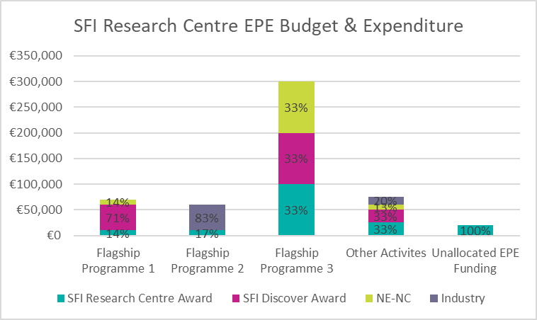
Figure 4 Example SFI Research Centre EPE Budget & Expenditure

  - Future plans for EPE programme
Detail areas identified for future development, including specific gaps in population engagement or resource development.

- KPI Performance (max. 10 pages, excluding images)

This section should begin with table of the Centre’s most recently validated KPI results against targets for the reporting period and cumulatively to date. For revised KPIs, the new KPI/metric blocks should be included in this section.

Discuss the Centre’s performance against each of the KPI targets for the reporting period and cumulatively to date. Please note, this is with the exception of KPIs for industry cost share and non-exchequer/non-commercial funding which will be discussed in section 7 below.

The Centre is requested to present the most recently validated KPIs so that this report matches the information provided to the review panel prior to the site review. However, subsequent discussion of each KPI in this section should include information on activity that is more recent than the validated KPIs. This can include a projection of how the recent outputs will affect the Centre’s progress against KPIs.

Example: A Centre’s validated KPIs indicate 0 spinouts against a target of 1, but a spinout has been formed in the period since the validated KPIs. The validated KPI table will show 0, but the spinout should be included in discussion, and in commentary of how KPIs will be/are being achieved.

Discussion should also include the challenges and setbacks that have been encountered, and the Centre’s strategy for achieving the KPI targets.

- Funding Diversification (max. 10 pages, excluding images)
This section should begin with a table of the Centre’s validated industry cost share and non-exchequer non-commercial results against targets for the reporting period and cumulatively to date.

Information should be provided for the Centre’s overall performance, as well as for each Spoke award held by the Centre.

As with Section 6, KPI performance, this section should include information on activity that is more recent than the validated results.

  - Industry engagement strategy and industry cost share
Describe the Centre’s commercial strategy and discuss the Centre’s performance against its industry cost share targets for the reporting period and cumulatively to date. Highlight any significant successes, setbacks and challenges during the reporting period, and comment on any changes to the Centre’s commercial strategy.

Discussion should be provided on the Centre’s overall performance, as well as on each Spoke award (i.e. status of Spoke CRAs) held by the Centre.

  - Non-exchequer non-commercial funding
Describe the Centre’s strategy to leverage non-exchequer/non-commercial funding, taking into account the following aspects:

- Collaborations in European funding programmes, including partner type (SMEs, MNCs, SFI Research Centres and non-national research centres)
- Influencing activities relevant to non-exchequer non-commercial funding that the Centre has been involved in during the reporting period, and the strategy for the coming year or longer-term (for instance, participation/membership of High-Level Groups, publication of white papers, liaison with NCPs/European contacts in the field, etc.)
- Identified Horizon 2020 funding opportunities, including high-level plans for significant multi-partner proposals for the coming year.

Discuss the Centre’s performance against NE-NC targets. Highlight any significant successes, setbacks and challenges during the reporting period and comment on any changes to the Centre’s non-exchequer non-commercial strategy.

  - Additional exchequer funding
Discuss other exchequer funding that the Centre has secured and detail the contribution that this funding has made to Centre activities and the delivery of the Centre’s strategy.

- Centre Impact (max. 10 pages, excluding images)
This section should begin with reference to the impact statement submitted as part of the original Centre proposal.

Before completing this section, please consult with SFI’s information and guidance on reporting on the impact arising from its funding, which can be found on the SFI website under Research Impact.

Discuss the impact arising from the Centre’s activities during the reporting period. Include individual case studies where the Centre has used its knowledge and research ideas to create impact, or to progress along a pathway to impact. Impacts can be at an economic, societal, international engagement, policy and public service, health and wellbeing, environment professional services, or human capacity level, either in Ireland or internationally.

Explicitly reference where impacts (or potential impacts) have arisen from Spoke or C2C awards.

- Communications (max. 10 pages, excluding images)

  - SFI Research Centre communications plan
Discuss how the Centre has used strategic communications to support its goals and to promote itself as a world leading SFI Research Centre during the previous year.

  - Communications activities
Provide an overview of national and international communications/marketing actions undertaken by the Centre, broken into different sections including:

- engagement with key stakeholders to promote the work of the Centre (media, industry, government, etc.),
- marketing/branding/advertising materials produced to promote the Centre,
- online activities, including social media platforms,
- media coverage over the reporting period.

Discuss communications challenges or setbacks that were encountered during the reporting period.

  - Communications case studies
Please provide 3-5 communications case studies highlighting the Centre’s top achievements. These can be highlights from research outputs, EPE, or other Centre activities.
These case studies should present short summaries of:
- challenge/background,
- action and engagement,
- impact,
- next steps (if relevant).

  - SFI Research Centre branding
Outline the actions taken to implement SFI Research Centre branding, as detailed in the agreed IUA-SFI guidelines.

Please indicate any outstanding actions relating to the updating of branding and give an estimated completion date for these.

  - Evaluation
Explain how you have evaluated communications activities and share any key statistics.

  - Future communications plan
Please provide an overview of key plans for the next year.
- Responses to Recommendations (max. 20 pages, excluding images)

This section should be devoted to setting out how the Centre has responded to the recommendations provided by a previous review panel. Recommendations should be dealt with separately, in clearly marked sections.

- Centre’s Transition to Next Phase (if applicable; max. 5 pages, excluding images)

This section should only be included in a Progress Report where the Research Centre is undergoing a 6-year review, and where funding has been awarded for the Centre’s next Phase.

The purpose of this section is to provide a summary of the key points outlining the Centre’s readiness to transition to the next Phase. This summary will be beneficial for the Review panel when completing their final report, as assessing this transition is one of the objectives of a 6-year review. It is important to note that material from other sections within this Progress Report can be re-used in this section.

  - Summary

Brief introductory summary of objectives, challenges and approach taken for transition to the next Phase.

  - Key Points

Outline the key steps taken for transition to the next Phase. Separate into different sections as appropriate, for instance transition of the Centre’s research themes, team, governance, funding strategy, etc.

- Clinical Trials and Clinical Investigations (if applicable; no page limit)

Refer to SFI's Clinical Trial and Clinical Investigation Policy before completing this section.

Trial Name | Lead Investigator | Objectives (incl. study endpoints) | Study phase and type (e.g. Phase I RCT) | Study Size (expected and current recruitment) | Start Date – End Date | Current Stage (recruitment/ treatment/ follow-up) | Trial Sponsor | HPRA Approval Required /Received? | Trial Location(s) | Insurance Details

APPENDIX I – Research Activities
(max. 60 pages for Annual Report; max. 120 pages for Progress Report, plus max 10 additional pages per Spoke and C2C award; page limits are exclusive of images)

Format guidance

Please note that this appendix should be submitted as a separate file and should have its own table of contents that links to each project. Projects should be grouped by research theme to enable easy navigation. If desired, this appendix can begin with the illustration of the Centre’s structure (section 1.2).

For each Centre project include a completed ‘Section A – Project overview’. In the case of a Progress Report (prior to a site review), ‘Section B – Detail’ should be included. For an Annual Report (i.e., in a year with no site review) only ‘Section A’ should be completed for each project. Section B should not be completed.

Only projects that were active during the reporting period should be reported on. Length and level of detail may vary significantly between projects.
Projects should be separated with a page break.

How to group activities into Centre projects

For the purposes of this appendix, a Centre ‘project’ is a grouping of research efforts into a coherent Centre platform or targeted project. Centres should not list each PhD/postdoc project as a separate Centre project with its own section. Instead, each project should have one or more PIs/FIs, and a number of postdocs and/or PhDs. Individually, these researchers may be working on their own thesis/papers, but for the purposes of presenting Centre activities in a succinct and coherent manner they should be grouped together as working towards a joint project goal. Centres should consult with their SFI Scientific Programme Manager for advice on project groupings, if required.

Each Spoke and C2C award associated with the Centre must be included as a distinct project, clearly labelled as being to the relevant award.

For multi-Centre Spoke awards, each SFI Research Centre involved in the award should report on the Spoke in their respective Annual/Progress Reports, with reporting concentrating on the Centre in question’s activity and progress in the Spoke.

Section A – Project overview

Project title | Name of the platform project/targeted project/Spoke/C2C, etc.
Research theme/strand
PIs | Provide the name and affiliation of each researcher.
FIs
Postdoctoral researchers
PhDs
Industry partners
Budget | Overall budget figure for this project, broken into SFI, industry cash/in-kind and NE-NC, as relevant.
Technology readiness level
Project start date – end date
Key publications | Key publications resulting from this project during the reporting period.
Other key outputs and impacts | Licences, patents, or other notable outputs or impacts during the reporting period.
Project status | Indicate if the project status is ‘Green’, ‘Orange’ or ‘Red’, based on internal assessments of progress against the workplan. Provide a very short reason for Orange or Red status.

Section B – Project detail

This section should only be included in a Progress Report, this section is not applicable for an Annual Report.

Goals and strategy

State the overarching objectives and approach of the project.

Note, for awards such as Centre-to-Centre partnerships and Spokes this section should include an introductory overview of the award, how it aligns with and is integrated into the Centre, and how it fits within the overall strategy of the Centre.

In the case of multi-Centre Spokes, this overview should make clear to external readers how the Spoke operates across the Centres involved, how the award has enabled existing Centres to link together and how such linkage has enabled the research programme to be delivered. It should also explain the Centre’s specific involvement in the Spoke that is being discussed in this report.

Summary of progress to date

Short summary of the overall progress made on this project. Comment on whether this work is ahead, on track, or behind schedule at this point. Is the budget expenditure on track, if not why?

Progress in the reporting period

Scientific overview of activities within this project. You may include images. Please include discussion of the contribution of any industry partners during the reporting period.
For Centre-to-Centre partnerships, please make clear which work was carried out by which Centre.
This is the main section for the discussion of research work undertaken, and it should be significantly larger than the other sections for this project.

Challenges and risks

Comment on any significant issues that have arisen during the reporting period, whether these have impacted on budget/deadlines. How has the Centre worked to reduce the impact of any setbacks?

Future direction

Short description of the planned direction of future work on this project.

